**OBJECT ORIENTED**

EXPERIMENT : 1

**PASSPORT VERIFICATION**

DEPLOYEMENT DIAGRAM

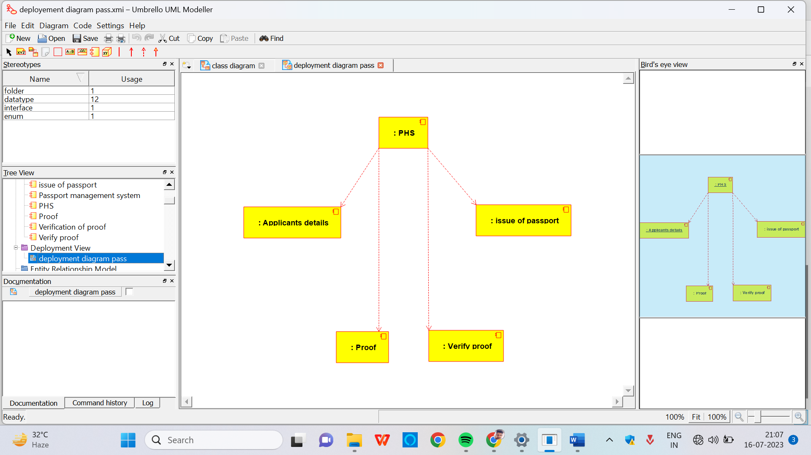

Component Diagram

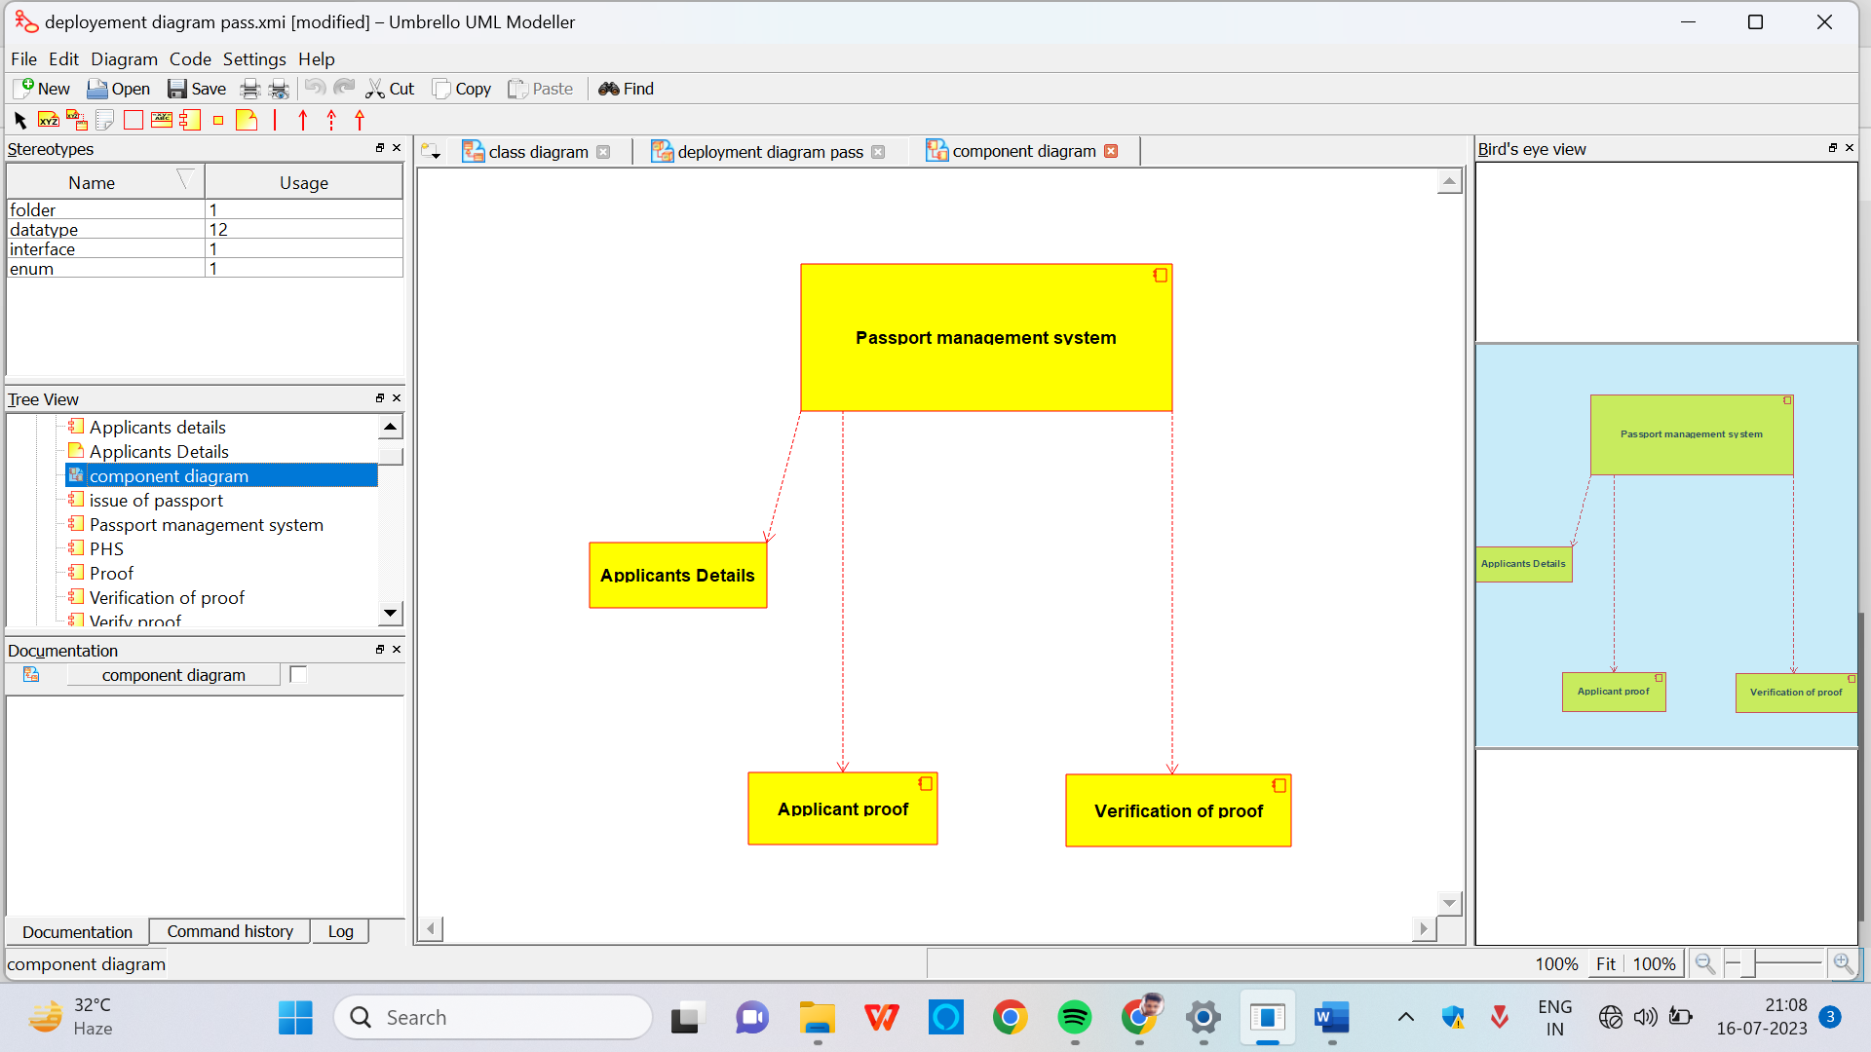

Collaboration Diagram

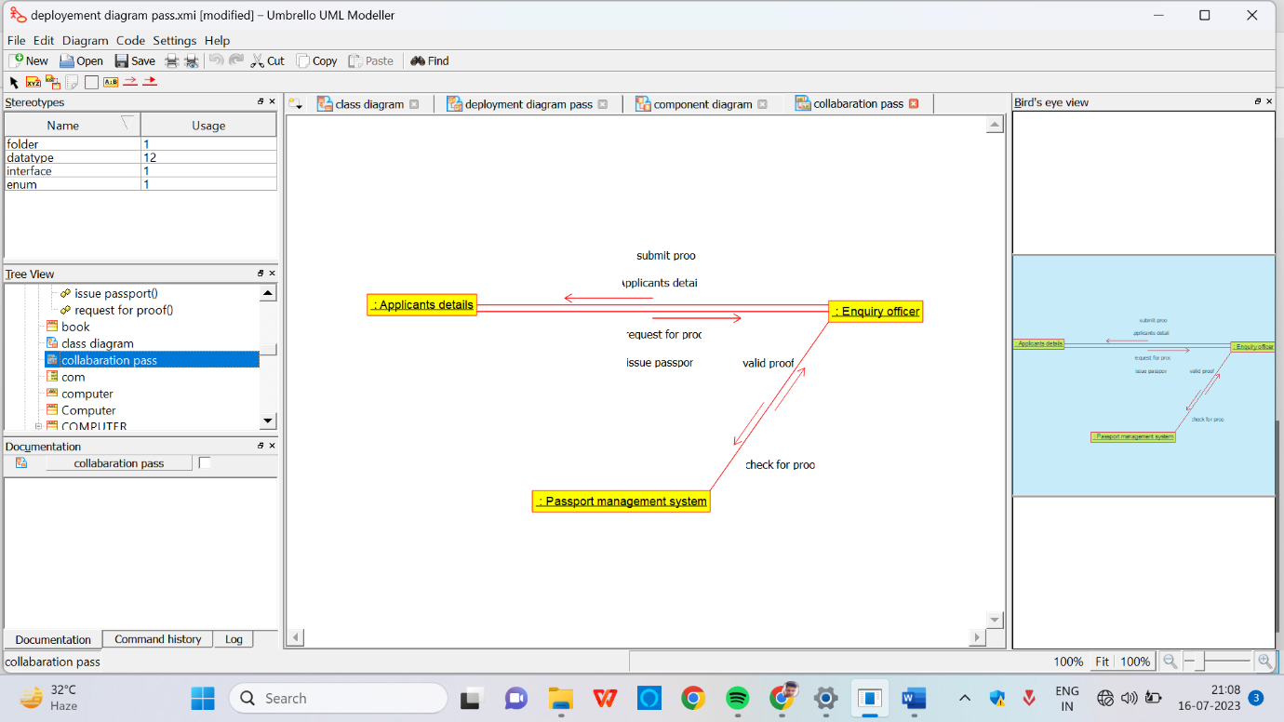

Activity Diagram

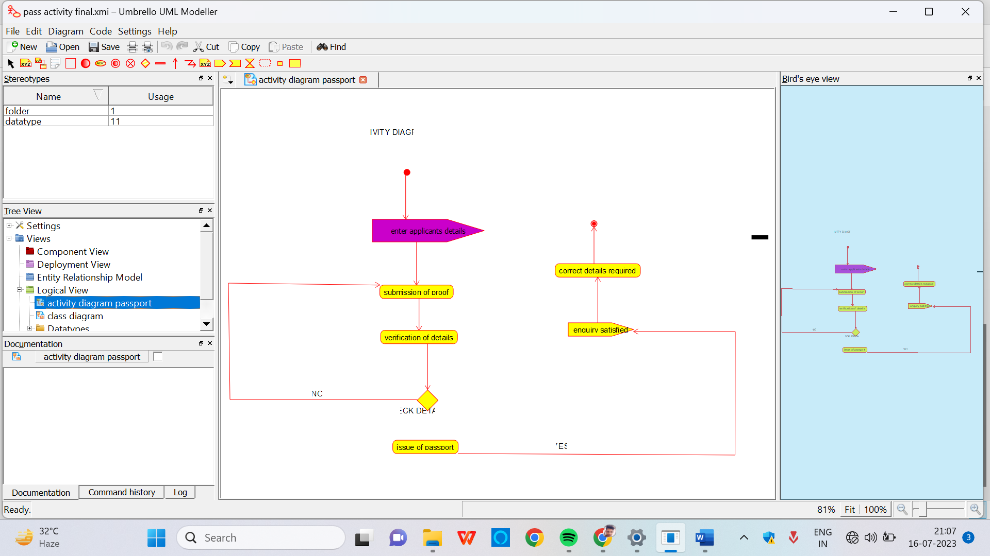

State chart diagram

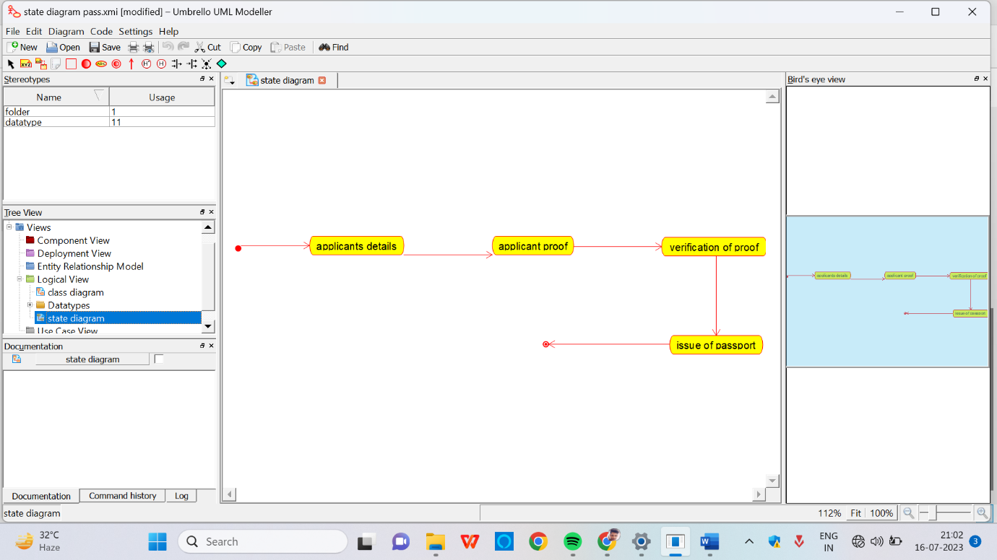

Sequence Diagram

